**Customer Engagement**

**and**

**Digital Excellence Pro**

**LEARNER'S GUIDE**

All rights reserved. This document is provided for the explicit use and guidance of parties approved by Edupedia Pte Ltd. As an information resource only. Any other use of this document or parts thereof, including reproduction, publication, distribution, transmission,

re-transmission, or storage in a retrieval system in any form, electronic or otherwise, for purposes other than that expressly stated above without the express permission of Edupedia Pte Ltd. is strictly prohibited. Printed in Singapore

Table of Contents

Course Overview 3

Warm-Up and Introduction 5

LU1: Digital Foundations in Customer Experience 6

1.1 Impact Factors and Digital Influences 7

1.2 Competitor Digital Presence Analysis 11

Learning Activity 1 – Competitor Research Analysis Report 13

LU2: Enhancing Customer Experience with In-Demand Digital Skills 15

2.1 Product Features, Benefits, and Digital Enhancements 16

2.2 Competitive Advantage through Digital Innovation 19

Learning Activity 2 – Digital Innovation Strategy Reflection 23

2.3: In-Demand Digital Skills for Customer Experience 25

LU3: Targeting Customer Experience 31

3.1 Target Customers and Digital Engagement 32

3.2: Leveraging Complementary Digital Offerings 33

Learning Activity 3 – Competitor Research Analysis Report 36

LU4: Implementing and Evaluating Customer Experience (CX) Improvements 40

4.1 Digital CX Cost-Benefit Analysis 41

4.2: Digital CX Strategy Effectiveness Evaluation 45

Learning Activity 4 – Evaluating and Improving Digital Customer Experience 47

# Course Overview

This Learner’s Guide aimed to present the content and activities of the course **Customer Engagement and Digital Excellence Pro** which is aligned to (TSC) Customer Experience Innovation, RET-INO-3001-1.1

The course is designed in response to identified performance gaps within the realm of digital customer engagement, Key performance gaps address include:

* **Digital Customer Interaction:** A notable deficiency in leveraging digital platforms for dynamic and effective customer interaction.
* **Utilization of Digital Tools for Customer Engagement:** Professionals often underutilize digital tools that can significantly enhance customer understanding and service personalization.
* **Strategies for Customer Experience Enhancement:** There's a gap in deploying effective strategies that leverage digital innovations to improve overall customer experience.

This course covers the following ability (A) and knowledge (K) elements

|  |
| --- |
| **Knowledge (K) Elements:**   * **K1**: Factors that impact customer experience. * **K2**: Methods to research products and/or services offered by competitors. * **K3**: Features and benefits of products and/or services that enhance customer experience. * **K4**: Organization's target customers. * **K5**: Complementary products and/or services that enhance customer experience.   **Ability (A) Elements:**   * **A1**: Determine features of the organization’s products and/or services that may enhance customer experience. * **A2**: Conduct research on competitors' products and/or services. * **A3**: Analyze gaps in customer experience offered by the organization and that of competitors. * **A4**: Identify ways in which customer experience may be enhanced to generate a competitive advantage for the organization. * **A5**: Conduct cost-benefit analysis of proposed improvements that may enhance customer experience. |

**Target Audience**

This course has been specifically designed for learners with all types of background

**Course Objectives**

At the end of this course, learners will be able to:

* Competency in Digital Customer Engagement: Ability to engage customers effectively across digital platforms, enhancing interaction and satisfaction.
* Mastery of Digital Tools: Skills to use digital tools for in-depth customer insights, leading to improved service customization.
* Strategic Application for Customer Experience: Understanding of how to apply digital innovations strategically to elevate the customer experience.

**Course Duration**

|  |  |  |
| --- | --- | --- |
| **Classroom Training** | **Final Assessment** | **Total** |
| 16 hours | 1 hour | 16 hours |

|  |  |
| --- | --- |
| **Final Assessment** | **Duration** |
| **Written Assessment - Reflective Journal** | **25 minutes** |
| **Practical Performance – Role Play** | **35 minutes** |
| **Total Assessment Duration** | **1 hour** |

# Warm-Up and Introduction

**“Fun Fact” Icebreaker Activity**

1. Introduce yourself
2. Share one fun fact about yourself!
3. Share a digital communication tip that you find useful or important.



# LU1: Digital Foundations in Customer Experience

In this Section, you will learn the following:

* **LO1**: Apply knowledge of factors, including digital, that impact customer experience to identify areas for improvement.
* **LO2**: Apply methods to research competitors' digital products and/or services to gather actionable insights.

This learning unit covers the following:

***Knowledge Elements***

* ***K1****: Factors that impact customer experience.*
* ***K2****: Methods to research products and/or services offered by competitors.*
* ***A2****: Conduct research on competitors' products and/or services.*

**

## 1.1 Impact Factors and Digital Influences

**Introduction**

Welcome to the first topic of Learning Unit 1 (LU1) on Digital Foundations in Customer Experience. In this section, we'll explore the various factors that influence customer experience, with a particular focus on how digital elements play a crucial role in shaping these experiences.

**Learning Objectives**

By the end of this topic, you will be able to:

* Understand and identify key factors that impact customer experience, particularly in the digital realm.
* Recognize how digital influences can be leveraged to improve customer satisfaction and engagement.

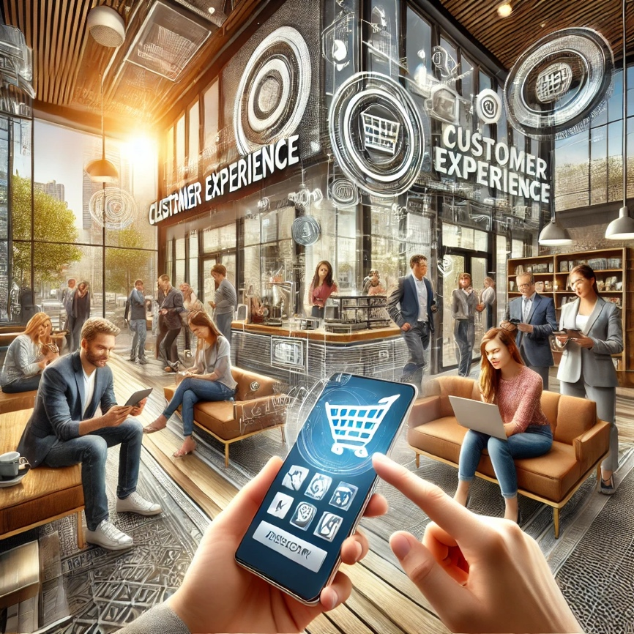**Understanding Customer Experience**

Customer experience (CX) refers to the overall impression a customer has of your brand or business across all touchpoints.

This experience is influenced by a range of factors, including product quality, service delivery, brand perception, and increasingly, digital interactions.

For many businesses, particularly in today’s digital age, customer experience is a key differentiator. Understanding the factors that impact CX, especially digital influences, is essential for improving customer satisfaction and fostering long-term loyalty.

**Key Factors Impacting Customer Experience**

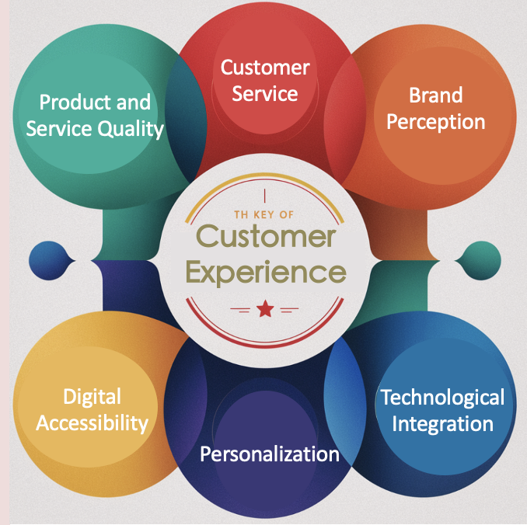

1. **Product and Service Quality**: The foundation of customer experience lies in the quality of the products or services you offer. However, even the best products need to be supported by strong digital strategies to ensure customers are aware of their value.
2. **Customer Service**: Excellent customer service, both online and offline, is critical. Digital tools such as live chat, email support, and social media platforms have become integral in providing timely and effective customer service.
3. **Brand Perception**: How your brand is perceived online—through your website, social media, and customer reviews—plays a significant role in shaping customer experience. A positive digital presence can enhance brand trust and loyalty.
4. **Digital Accessibility**: In today’s world, ensuring that your digital platforms are easy to navigate and accessible to all users, including retirees and homemakers, is vital. This includes user-friendly websites, mobile apps, and responsive customer service channels.
5. **Personalization**: Customers expect personalized experiences that cater to their individual needs and preferences. Digital tools allow businesses to gather data and tailor their offerings to meet these expectations, enhancing overall customer satisfaction.
6. **Technological Integration**: Seamless integration of technology in customer interactions, such as automated systems for handling inquiries or AI-driven recommendations, can significantly improve the efficiency and effectiveness of customer service.

**Digital Influences on Customer Experience**

The digital landscape has dramatically altered how businesses interact with their customers. Here are some key digital influences:



1. **Social Media**: Platforms like Facebook, Instagram, and Twitter are powerful tools for engaging with customers, addressing their concerns, and promoting products or services. Social media allows businesses to interact with customers in real-time, fostering a sense of community and immediacy.
2. **E-Commerce Platforms**: Online shopping has become a primary mode of purchasing for many customers. Ensuring that your e-commerce platform is user-friendly, secure, and efficient is essential for providing a positive customer experience.
3. **Mobile Accessibility**: With the increasing use of smartphones, customers expect businesses to offer mobile-friendly services. This includes responsive websites, mobile apps, and easy access to customer support via mobile devices.
4. **Data Analytics**: Businesses can now collect and analyze customer data to understand behaviors, preferences, and trends. This information is invaluable for making informed decisions that improve customer experience.
5. **Online Reviews and Feedback**: Customer reviews on platforms like Google, Yelp, and TripAdvisor can significantly influence public perception. Encouraging positive reviews and promptly addressing negative feedback is crucial for maintaining a good digital reputation.

## 1.2 Competitor Digital Presence Analysis

**Methods to Research Competitors' Products and Services**

1. **Online Marketplaces and E-Commerce Platforms**
   * **Example**: Suppose you are analyzing the online presence of a competitor in the electronics industry, like Samsung. You can check their product listings on Shopee to observe pricing, product descriptions, and customer reviews.
2. **Competitor Websites**
   * **Example**: If you want to analyze the website of Apple, you could explore various product pages, their blog, and customer service sections to understand their offerings and customer engagement strategies.

1. **Social Media Analysis**
   * **Example**: To analyze how our Ministers engage with their audience on TikTok, you could follow their account and monitor their posts, customer interactions, and promotional campaigns.
2. **Customer Reviews and Ratings**
   * **Example**: Analyzing customer reviews for a hotel on Google reviews or TripAdvisor can provide insights into customer satisfaction and areas of improvement.
3. **Search Engine Results and SEO Analysis**
   * **Example**: You can use Google’s free tools like **Google Search Console** and **Google Trends** to analyze the SEO strategy of a competitor such as **RedMart** grocery in Singapore. These tools allow you to see what keywords RedMart is ranking for, track their website’s search performance, and identify trending topics in Singapore that could affect their SEO strategy.
4. **Industry Reports and Market Research**
   * **Example**: Accessing an industry report on the global retail market via Statista can give you insights into market trends and competitor performance.
   * **URL**: [www.statista.com](http://www.statista.com)
5. **Mystery Shopping**
   * **Example**: Suppose you are conducting mystery shopping at **NTUC FairPrice** in Singapore. You would visit a physical store or shop online, interact with staff or customer service, and assess the overall shopping experience. This method provides firsthand insights into their customer engagement strategies and service quality.
   * **URL**: [www.ipsos.com/en-sg/mystery-shopping](http://www.ipsos.com/en-sg/mystery-shopping)
6. **Web Analytics Tools**
   * **Example**: Using **Google Analytics**, you can analyze the traffic sources and audience behavior of a competitor’s website, such as Target.

## Learning Activity 1 (Role Play) – Competitor Research Analysis Report

To solidify your understanding, complete the following activity:

Form a group of 4 to 5 learners,

1. Select a business to start with

2. Each group should choose 2 of the methods outlined above

* 1. gather information about your competitor’s products and services.
  2. Write a brief report summarizing your findings, focusing on what makes their customer experience strong or where they might be vulnerable.
  3. use the ”Template 1” provided for your findings

**Template 1**

|  |  |
| --- | --- |
| **Competitor Research Analysis Report** | |
| **Competitor A**  Company name  ***Method used*** | - Price: [List observed prices]  - Promotions: [List any promotions or discounts]  - Product Descriptions: [Brief description of how they present their products]  - Customer Reviews: [Summary of customer feedback, common themes] |
| What did you learn about the competitor that surprised you? | |
| What are your recommendations/ or Suggestions your organization could use to improve your own customer experience? | |
|  | |

# LU2: Enhancing Customer Experience with In-Demand Digital Skills

In this Section, you will learn the following:

* **LO3:** Demonstrate the application of digital services to enhance customer experience.
* **LO4:** Develop strategies that use digital innovation to secure a competitive advantage.

This learning unit covers the following:

***Knowledge Elements***

* ***K3:*** *Features and benefits of products and/or services that enhance customer experience.*
* ***A1:*** *Determine features of the organization’s products and/or services that may enhance customer experience.*
* ***A4:*** *Identify ways in which customer experience may be enhanced to generate a competitive advantage for the organization.*



## 2.1 Product Features, Benefits, and Digital Enhancements

**Introduction**

Welcome to Learning Unit 2, let’s explore how digital services and tools can be leveraged to enhance customer experience. In this section, we'll delve into the features and benefits of products and services that can be digitally enhanced to meet and exceed customer expectations.

**Learning Objectives**

By the end of this topic, you will be able to:

* Identify the key features of products and services that can be enhanced through digital means.
* Understand how these enhancements contribute to a superior customer experience.

**Understanding Product Features and Benefits**

Product features refer to the characteristics of a product or service—what it does, how it works, and the specific components or capabilities it includes. Benefits, on the other hand, describe the advantages that customers gain from using the product or service.

In the context of customer experience, digital enhancements can amplify these benefits, making the product more accessible, user-friendly, or efficient. Let's examine some ways this can be achieved.

**Key Digital Enhancements for Customer Experience**

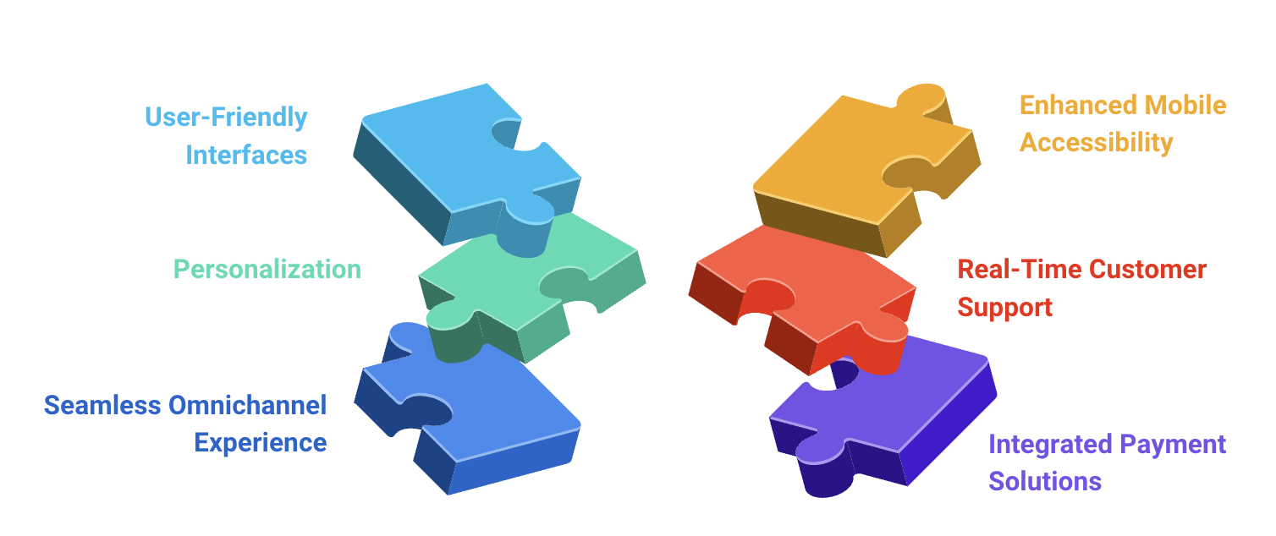

1. **User-Friendly Interfaces**
   * **Description**: A user-friendly interface is one that is intuitive, easy to navigate,

and requires minimal effort from the customer to achieve their goals.

* + **Example**: An e-commerce platform like Shopee enhances user experience by offering a streamlined checkout process, personalized recommendations,

and easy navigation across various product categories.

* + **Benefit**: Customers experience less frustration and are more likely to complete their transactions, leading to higher satisfaction and repeat business.

1. **Personalization**
   * **Description**: Personalization involves tailoring the user experience to meet the individual preferences and needs of each customer.
   * **Example**: Netflix uses algorithms to recommend shows and movies based on a user’s viewing history, creating a personalized entertainment experience.
   * **Benefit**: Personalization can significantly increase customer engagement and loyalty, as customers feel that the service is specifically catered to their interests.
2. **Seamless Omnichannel Experience**
   * **Description**: An omnichannel experience ensures that customers can interact with a brand across multiple platforms (e.g., in-store, online, mobile app) seamlessly.
   * **Example**: A brand like Apple allows customers to start a purchase on their website, continue it on their mobile app, and finalize it in a physical store without any loss of information or continuity.
   * **Benefit**: This seamless transition across channels makes the shopping experience more convenient and satisfying for customers.
3. **Enhanced Mobile Accessibility**
   * **Description**: With more users accessing the internet via mobile devices, optimizing products and services for mobile use is crucial.
   * **Example**: Food delivery services like GrabFood ensure their apps are optimized for mobile, providing features such as easy order tracking, quick reordering, and in-app customer support.
   * **Benefit**: Mobile accessibility increases the likelihood that customers will use the service regularly, especially when they are on the go.
4. **Real-Time Customer Support**
   * **Description**: Real-time support allows customers to get immediate assistance through live chat, chatbots, or phone support.
   * **Example**: Many banks offer live chat services on their websites, enabling customers to get instant answers to their queries without having to visit a branch.
   * **Benefit**: Real-time support can enhance customer satisfaction by resolving issues quickly and efficiently, reducing the need for follow-up interactions.
5. **Integrated Payment Solutions**
   * **Description**: Offering multiple payment options, including digital wallets and installment plans, can make transactions smoother and more flexible for customers.
   * **Example**: E-commerce platforms like Lazada offer a variety of payment methods, including credit/debit cards, digital wallets, and installment plans.
   * **Benefit**: Flexible payment options can remove barriers to purchase, making it easier for customers to complete their transactions.

## 2.2 Competitive Advantage through Digital Innovation

**Understanding Competitive Advantage**

Competitive advantage refers to the factors that allow an organization to outperform its competitors. This could be through offering superior products, providing exceptional customer service, or innovating faster than others in the industry. In today’s digital age, leveraging technology and digital tools is often key to creating and sustaining this advantage.

**Key Areas of Digital Innovation for Competitive Advantage**

1. **Artificial Intelligence and Machine Learning**
   * **Description**: AI and machine learning can be used to automate processes, provide personalized customer experiences, and gain insights from large data sets.
   * **Example**: Amazon uses AI to recommend products based on customer behaviour, increasing sales through personalized suggestions.
   * **Benefit**: Implementing AI-driven solutions can help your organization predict customer needs, streamline operations, and improve decision-making.
2. **Data-Driven Marketing**
   * **Description**: Using customer data to inform marketing strategies allows for more targeted and effective campaigns.
   * **Example**: Brands like Sephora use data from customer purchases and online behaviour to send personalized offers and recommendations.
   * **Benefit**: Data-driven marketing can increase customer engagement and conversion rates by delivering relevant content to the right audience.
3. **Blockchain Technology**
   * **Description**: Blockchain offers a secure and transparent way to manage transactions, track supply chains, and protect data.
   * **Example**: IBM’s Food Trust blockchain network enables greater transparency in food supply chains, enhancing trust with consumers.
   * **Benefit**: Implementing blockchain can enhance security, reduce fraud, and increase transparency, all of which can strengthen customer trust and loyalty.



1. **Augmented Reality (AR) and Virtual Reality (VR)**
   * **Description**: AR and VR can create immersive experiences that enhance product visualization, training, and customer engagement.
   * **Example**: IKEA uses AR to allow customers to visualize furniture in their homes through the IKEA Place app.
   * **Benefit**: AR and VR can help customers make more informed purchasing decisions by providing a more interactive and engaging shopping experience.
2. **Omnichannel Integration**
   * **Description**: Seamless integration across various customer interaction channels ensures a consistent experience whether online, in-store, or on mobile.
   * **Example**: Starbucks offers an integrated experience where customers can order via their mobile app and pick up in-store while earning rewards across all channels.
   * **Benefit**: Omnichannel integration helps retain customers by providing a consistent and convenient experience across all touchpoints.
3. **Sustainability and Green Technology**
   * **Description**: Incorporating sustainable practices and green technology can attract eco-conscious consumers and reduce operational costs.
   * **Example**: Tesla’s focus on sustainable energy solutions not only attracts environmentally conscious consumers but also positions the brand as a leader in green technology.
   * **Benefit**: Sustainability can differentiate your brand in a competitive market, appeal to a growing demographic of eco-friendly consumers, and potentially reduce long-term costs.

**Digital Innovation Strategy –** an example will look like this

|  |  |  |  |  |  |
| --- | --- | --- | --- | --- | --- |
| **Innovation** | **Must-Have** | **Good-to-Have** | **Why** | **Budget Estimate** | **Expected ROI** |
| **Artificial Intelligence and Machine Learning** | Yes |  | Crucial for automating processes, personalizing experiences, and gaining insights from data. | $75,000 - $100,000 | High - Improves decision-making and customer satisfaction |
| **Data-Driven Marketing** | Yes |  | Vital for targeted marketing strategies, increasing engagement and conversion rates. | $50,000 - $80,000 | High - Enhances customer engagement and drives conversions |
| **Blockchain Technology** |  | Yes | Enhances security and transparency, which builds trust and reduces fraud. | $100,000 - $150,000 | Moderate - Strengthens customer trust and loyalty |
| **Augmented Reality (AR) and Virtual Reality (VR)** |  | Yes | Provides immersive experiences, aiding in informed purchasing decisions. | $60,000 - $90,000 | Moderate - Increases customer engagement and satisfaction |
| **Omnichannel Integration** | Yes |  | Ensures a consistent customer experience across all touchpoints, increasing retention. | $70,000 - $100,000 | High - Improves customer loyalty and retention |
| **Sustainability and Green Technology** |  | Yes | Attracts eco-conscious consumers and positions the brand as a leader in sustainability. | $100,000 - $200,000 | Moderate - Appeals to eco-friendly consumers, reduces long-term costs |

**Explanation of the Digital Innovation**

* **Must-Have:** Mark "Yes" if the innovation is critical for your business and needs immediate implementation.
* **Good-to-Have**: Mark "Yes" if the innovation is beneficial but can wait.
* **Why:** Provide a brief reason for categorizing the innovation as a must-have or good-to-have.
* **Budget Estimate:** Enter the estimated cost for implementing the innovation.
* **Expected ROI:** Quantify the return on investment with specific figures (e.g., 20% increase in sales, 15% reduction in operational costs).

## Learning Activity 2 (Role Play) – Digital Innovation Strategy Reflection

Return to your group of 4 to 5 learners,

**Instructions**: Think about the key areas of digital innovation that could give your business a competitive edge. Reflect on the different innovations that could be applied to your business and answer the following questions:

1. **Which Key Area of Digital Innovation is a Must-Have for Your Business?**
   * Explain why this innovation is crucial and how it fits with your business goals.
2. **Which Innovations Are Good to Have, but Not Essential?**
   * Identify which innovations could help your business but aren’t immediately necessary. Explain why these are "good to have" and how they might benefit your business in the future.
3. **Why Did You Prioritize These Innovations?**
   * Discuss why you chose to focus on certain innovations. Think about customer needs, current market trends, and how these innovations could help you stand out from the competition.
   * Use the ”Template 2” provided for your findings

**Template 2: Digital Innovation Strategy**

|  |  |  |  |  |  |
| --- | --- | --- | --- | --- | --- |
| **Innovation** | **Must**  **Have** | **Good**  **to**  **Have** | **Why** | **Budget**  **Estimate** | **Expected**  **ROI** |
| **Artificial**  **Intelligence**  **and Machine**  **Learning** |  |  |  |  |  |
| **Data-Driven**  **Marketing** |  |  |  |  |  |
| **Blockchain**  **Technology** |  |  |  |  |  |
| **Augmented Reality**  **(AR) and Virtual**  **Reality (VR)** |  |  |  |  |  |
| **Omnichannel**  **integration** |  |  |  |  |  |
| **Sustainability and**  **Green Technology** |  |  |  |  |  |

## 2.3: In-Demand Digital Skills for Customer Experience

In today’s digital landscape, the ability to effectively engage with customers is crucial for enhancing their experience and ensuring long-term loyalty. This topic will focus on the essential digital skills that are in high demand for improving customer interactions. We will explore how these skills can be applied in customer service operations, using the 5 Cs of Communication—Clarity, Cohesiveness, Correctness, Concreteness, and Conciseness—as guiding principles.

**1. Digital Marketing and Social Media Management**

* **Description**: Skills in digital marketing, including SEO, content marketing, and social media management, are vital for engaging customers online and promoting brand awareness.
* **Why Important**: Effective digital marketing strategies increase customer engagement, drive traffic, and enhance the overall customer experience by reaching customers where they are most active.

**2. Artificial Intelligence (AI) and Machine Learning (ML)**



* **Description**: Understanding how to leverage AI and ML technologies to automate customer interactions, personalize experiences, and analyze large datasets.
* **Why Important**: AI-driven tools like chatbots and recommendation engines improve response times, enhance personalization, and provide customers with seamless experiences.

**3. Omnichannel Communication Management**

* **Description**: The ability to manage customer communications across multiple channels (e.g., email, social media, live chat) while ensuring a consistent and cohesive experience.
* **Why Important**: Customers expect seamless interactions across various touchpoints, and managing these effectively is key to delivering a superior CX.

**4. Content Creation and Management**

* **Description**: The ability to create and manage engaging, relevant content for customers across digital platforms.
* **Why Important**: High-quality content enhances customer engagement, educates customers, and supports the overall brand experience.

These skills are crucial for creating a cohesive, personalized, and engaging customer experience across digital platforms, ensuring that businesses can effectively connect with and serve their customers.

**Engaging customers**

* + - 1. **The 5 Cs of Communication**



**Clarity:**

Clarity is fundamental when communicating with customers, especially in digital interactions where misunderstandings can easily occur. When responding to customer inquiries or concerns, use simple and direct language. Avoid jargon or overly technical terms unless necessary, and always aim to provide a clear and straightforward answer. For example, if a customer asks about a return policy, clearly outline the steps they need to follow, such as: “To return your item, please visit our Returns page and fill out the form within 30 days of purchase.

**Cohesiveness:**

Cohesiveness ensures that your communication is logical and consistent across all touchpoints. Whether you’re engaging with a customer via email, social media, or live chat, your messaging should be unified and aligned with your brand’s voice. This means that the tone, style, and information should be consistent, regardless of the platform. If a customer begins an inquiry on social media and continues it via email, ensure that your responses follow the same thread of communication without needing the customer to repeat themselves.

**Correctness:**

Correctness is about providing accurate and reliable information to your customers. In digital interactions, this is particularly important because misinformation can quickly lead to dissatisfaction and loss of trust. Always verify the details you are providing, whether it’s about product availability, pricing, or company policies. If you’re unsure about something, it’s better to double-check than to give a potentially incorrect answer. For instance, if a customer asks about shipping times, respond with verified information: “Your order will be shipped within 3-5 business days.”

**Concreteness:**

Concreteness in communication involves giving customers specific and detailed information that supports your message. When dealing with customer queries or complaints, back up your responses with tangible details or examples. For example, if a customer is unhappy with a product, you could say: “I understand your concern. This product is designed to last for up to five years with proper care. Here’s a link to our care instructions to help you get the most out of it.” Providing concrete information helps to reassure the customer and can prevent further issues.

**Conciseness**:

Conciseness means delivering your message in a clear and straightforward manner, without unnecessary details. In digital communication, where customers often expect quick responses, it’s important to get to the point efficiently. For example, if a customer asks how to track their order, a concise response might be: “You can track your order by clicking on the tracking link sent to your email.” This approach respects the customer’s time and ensures that the information provided is easily digestible.

**Expanding on Customer Engagement Skills**

* + - 1. **Active Listening**

Active listening is crucial in understanding the customer’s needs and concerns. Even in a digital context, it’s important to demonstrate that you are paying attention to what the customer is saying. This can be achieved by summarizing their query or concern before providing a response, ensuring that you have understood their issue correctly. For example, if a customer is frustrated with a product, acknowledge their feelings before offering a solution.

* + - 1. **Professional and Empathetic Responses**

When handling customer queries, maintaining professionalism while showing empathy is key. Customers appreciate when their issues are acknowledged and treated with importance. Always begin by expressing understanding of the customer’s situation, such as saying, “I understand how frustrating this must be for you.” Follow up with a clear, actionable solution or next step. Empathy helps in building rapport and trust, which are vital for long-term customer relationships.

1. **Handling Difficult Conversations**

Dealing with upset or angry customers can be challenging, especially online where tone can be easily misinterpreted. It is important to remain calm and patient, focusing on resolving the issue rather than responding emotionally. Use phrases like, “Let’s work together to resolve this,” to show that you are on the customer’s side. If the conversation becomes too heated, it might be necessary to escalate the issue to a supervisor or offer to continue the discussion over a more private channel, such as a phone call or direct email.

1. **Timely Responses**

In the digital world, customers expect quick responses. Whether it’s an inquiry on social media or a question submitted via email, aim to respond as quickly as possible, ideally within a few hours. If you need more time to resolve an issue, let the customer know that you are working on it and provide an estimated timeframe for when they can expect a resolution. Timely communication shows that you value the customer’s time and are committed to addressing their needs.

1. **Consistency Across Channels**

Customers may reach out to your organization through various channels, including social media, email, live chat, or phone. It is important to maintain consistency in how you engage with customers across these platforms. Ensure that your tone, messaging, and the level of service provided are consistent, regardless of the channel. This helps in creating a seamless experience for the customer, reinforcing their trust in your brand.

**Personalization of Interactions**

Personalizing your interactions with customers can significantly enhance their experience.

Use the customer’s name, reference previous interactions, and tailor your responses to their

specific needs. For example, if a customer frequently purchases certain products, you might

suggest related items that could interest them. Personalization makes customers feel valued

and understood, which can lead to increased loyalty and satisfaction.

**Practical Application: Engaging with Customers Online**

To effectively engage with customers, consider the following best practices:

* **Use Positive Language**: Frame your responses in a positive manner, even when delivering bad news. For example, instead of saying, “I don’t know when this will be back in stock,” you could say, “We’re expecting new stock soon, and I’ll make sure to notify you as soon as it’s available.”
* **Follow Up After Resolution**: After resolving an issue, follow up with the customer to ensure they are satisfied with the outcome. This shows that you care about their experience and are committed to their satisfaction.
* **Stay Updated on Digital Etiquette**: Digital communication trends evolve, and it’s important to stay informed about the latest best practices for online customer engagement. This includes understanding the nuances of communicating on different platforms, such as the informal tone often used on social media versus the more formal tone required in email communication.

# LU3: ****Targeting Customer Experience****

In this Section, you will learn the following:

* **LO5:** Identify two targeted customer markets.
* **LO6:** Explore complementary digital products/services to enhance customer experience.

This learning unit covers the following:

***Knowledge Elements***

* ***K4:*** *Organisation's target customers*
* ***K5:*** *Complementary products and/or services that enhance customer experience*



## 3.1 Target Customers and Digital Engagement

**Introduction**

In today’s digital landscape, effectively targeting customer markets and leveraging complementary digital offerings are essential for creating a superior customer experience. This unit covers two critical areas:

**Learning Objectives**

By the end of this unit, you will be able to:

1. Identify and Segment Target Customer Markets
2. Leverage Complementary Digital Offerings

**Identifying Target Customer Markets**

**Understanding Your Target Market**

* **Definition**: A target market is a specific group of customers that your business aims to reach with its products and services. These customers are identified based on various factors such as demographics, behaviour, needs, and preferences.
* **Importance**: Identifying the right target market is essential for creating effective marketing strategies, optimizing product offerings, and ensuring that your customer engagement efforts are well-directed.



**Segmentation strategy**

* **Demographic Segmentation**: This involves dividing your customer base based on demographic factors such as age, gender, income level, education, and occupation. For example, a company might target young professionals aged 25-35 with a high disposable income.
* **Behavioural Segmentation**: Focuses on the behaviours and decision-making patterns of your customers, such as purchasing habits, brand loyalty, and product usage. For instance, targeting customers who frequently shop online or are loyal to eco-friendly products.
* **Psychographic Segmentation**: This involves understanding your customers’ lifestyles, values, interests, and opinions. For example, targeting health-conscious consumers who prioritize organic and sustainable products.
* **Geographic Segmentation**: This involves dividing the market based on geographic boundaries such as countries, regions, or cities. For example, a brand might target urban customers in large metropolitan areas.

**Identify Your Users**

It’s essential to recognize who will be the primary users of your knowledge base. Is it designed to assist customers, empower employees, or inform partners? Each group has unique requirements. For example, customers generally look for immediate problem-solving guides and tutorials, whereas partners might need more comprehensive technical details.

* **User Needs**: Take a proactive approach to understand what your users are seeking. Utilize brief surveys or delve into the patterns emerging from support tickets to identify common issues. This ensures that your knowledge base is not just a repository of information but a solution center addressing real-time user challenges.
* **Set Clear Objectives Goals**: Knowing your users, outline specific, actionable objectives for your knowledge base. Whether it's to streamline customer support, enhance user satisfaction, or facilitate smoother onboarding, your goals should be tangible. Set quantifiable targets like aiming to "reduce customer service operational costs by 10% over the next quarter" or "cut down on average resolution man-hours by 20% within six months
* **KPIs for Performance Tracking**: Establish KPIs that not only track the effectiveness of your knowledge base but also align with your organizational ambitions. These KPIs should serve as benchmarks for success, ensuring that your knowledge base is a strategic asset contributing to overall company performance.

## 3.2: Leveraging Complementary Digital Offerings

In today’s competitive marketplace, enhancing customer experience goes beyond just offering a single product or service. By leveraging complementary digital products and services, organizations can create a more cohesive and satisfying customer journey. In this topic, we will explore how to identify and integrate complementary digital offerings to improve customer experience and increase customer loyalty.

**Understanding Complementary Digital Offerings**

**1. Definition and Importance**

* **Complementary digital offerings** are products or services that enhance the value of your primary offerings by providing additional benefits or convenience to customers. These can include digital tools, platforms, or services that work seamlessly with your core products to create a more comprehensive customer experience.
* **Importance**: Integrating complementary offerings can differentiate your brand, improve customer satisfaction, and increase overall engagement. It also allows you to meet a broader range of customer needs, making your brand a one-stop solution for their requirements.

**2. Examples of Complementary Digital Offerings**

* **E-commerce and Mobile Apps**: An online retailer might develop a mobile app that allows customers to track orders, receive personalized promotions, and manage their shopping lists.
* **Social Media and Content Platforms**: A fitness brand could offer workout plans through a subscription-based app, complementing their physical products like fitness equipment or apparel.
* **Customer Support Tools**: A software company might integrate a live chat service or AI-driven chatbot to provide instant support, complementing their primary software products.
* **Loyalty Programs and Gamification**: Implementing a digital loyalty program that rewards customers for purchases and engagement, thus enhancing the overall customer experience by encouraging repeat business.

**Developing a Digital Engagement Strategy**

Once complementary digital offerings are identified, the next step is to develop a digital engagement strategy that effectively integrates these offerings into your overall customer experience. This strategy should focus on how to best utilize various digital platforms and tools to engage customers and drive the adoption of the complementary offerings.

**1. Selecting Digital Platforms**

* **Social Media Platforms**:
  + **Facebook**: Use Facebook to create targeted ads and posts that promote your complementary offerings. Engage with customers through comments, polls, and direct messages to build a community around your brand.
  + **Instagram**: Leverage Instagram Stories, Reels, and IGTV to showcase how your complementary offerings can be used in real-life scenarios. This visual approach can be particularly effective for lifestyle and consumer products.
  + **TikTok**: Create short, engaging videos that demonstrate the unique benefits of your complementary offerings. TikTok’s algorithm can help your content reach a wider, relevant audience.
* **Video Platforms**:
  + **YouTube**: Develop tutorial videos, product demos, and customer testimonials that highlight the value of your complementary offerings. YouTube is an excellent platform for providing in-depth content that educates and informs customers.
* **Chatbots and AI-Driven Tools**:
  + **Chatbots**: Implement chatbots on your website or mobile app to provide instant customer support and answer queries about your complementary offerings. Chatbots can help customers navigate your offerings and resolve issues quickly.
  + **AI Personalization Tools**: Use AI tools to personalize customer interactions based on their behaviour and preferences. For example, an AI-driven recommendation engine could suggest complementary products based on past purchases.

1. **Engagement Tactics**



* **Content Marketing**:
  + Create blogs, articles, and social media posts that explore the benefits of your complementary offerings. Use SEO strategies to ensure this content is discoverable by potential customers.
  + Develop email campaigns that provide customers with valuable information and updates about your offerings, including exclusive promotions or discounts.
* **Influencer Collaborations**:
  + Partner with influencers who align with your brand values to promote your complementary offerings. Influencers can provide authentic endorsements that resonate with their followers.
* **Interactive Campaigns**:
  + Launch interactive campaigns such as contests, polls, or challenges on social media that encourage customers to engage with your complementary offerings. For example, a fitness brand could run a challenge where customers share their workout routines using your products.
* **Customer Testimonials and Case Studies**:
  + Collect and share customer testimonials or case studies that highlight how others have benefited from your complementary offerings. This social proof can be very persuasive for potential customers.

## Learning Activity 3 (Role Play) – Competitor Research Analysis Report

Return to your group of 4 to 5 learners,

* + - 1. **Identify the Target Market:**

Use the segmentation methods (Demographic, behavioural, psychographic, and geographical) to circle the relevant characteristics that describe your target market.

* + - 1. **Select on the Digital Engagement Strategy**:

Choose the digital platforms where your target market is most active.

* + - 1. **Create and Post Content:** Craft a message or video that promotes your business. Focus on engaging your target audience, then choose the appropriate platform (TikTok, Facebook, etc.) and publish your content.
      2. **Share in WhatsApp**: Take a snapshot of your post and share it in the WhatsApp group.

use the template below for your findings

**Template 3**

**Table: Identifying a Target Market Using Segmentation Methods**

|  |  |
| --- | --- |
| **Segmentation Method** | Target Market: |
| **Demographic Segmentation** | - Targeted group: - Age:  - Income:  - Education:  - Occupation: |
| **Behavioural Segmentation** | Shopping and Lifestyle Preferences - High engagement with:       ☐ E-commerce platforms (e.g., Lazada, Shopee)       ☐ Retail shopping malls       ☐ Food delivery apps (e.g., GrabFood, Foodpanda)       ☐ Health and fitness services (e.g., gyms, yoga studios)       ☐ Travel and leisure activities  - Loyalty to brands offering:       ☐ Convenience       ☐ Technology-driven solutions       ☐ Sustainable and eco-friendly practices       ☐ Value for money       ☐ Prestige and luxury |

|  |  |
| --- | --- |
| **Psychographic Segmentation** | Singaporean Professionals and Residents  - Lifestyle:       ☐ Tech-savvy, early adopters of new technology       ☐ Health-conscious, prioritizing wellness and fitness       ☐ Family-oriented, focusing on family activities and products       ☐ Socially conscious, supporting ethical and eco-friendly  brands       ☐ Status-driven, seeking luxury and premium products       ☐ Cost-conscious, prioritizing value for money       ☐ Age gracefully, focusing on anti-aging and wellness products  - Values:       ☐ Innovation and efficiency       ☐ Work-life balance       ☐ Community and social responsibility       ☐ Quality and reliability       ☐ Luxury and prestige |

|  |  |
| --- | --- |
| **Geographic Segmentation** | Residents of Singapore - Location:       ☐ Central Business District (CBD)       ☐ Heartland and Suburban areas (e.g., Ang Mo Kio, Bedok,  Tampines, Jurong)       ☐ Newer residential areas (e.g., Punggol, Sengkang)       ☐ Sentosa and high-end residential areas  - Environment:       ☐ Fast-paced, tech-oriented       ☐ High availability of public transport       ☐ Close proximity to shopping malls and recreational facilities       ☐ Community-centred, with access to local markets and  community centres |
| **Digital Engagement Strategy** | Selected Strategy - Preferred Digital Platforms:       ☐ Social media platforms (e.g. Facebook, Tik tok)       ☐ Email marketing       ☐ E-commerce websites       ☐ Mobile apps  - Key Engagement Tactics:       ☐ Personalized marketing (e.g., targeted ads, personalized  emails)       ☐ Content marketing (e.g., blogs, videos)       ☐ Loyalty programs and rewards       ☐ Influencer collaborations |

# LU4: Implementing and Evaluating Customer Experience (CX) Improvements

In this Section, you will learn the following:

* **LO7:** Conduct a digital cost-benefit analysis for proposed customer experience improvements.
* **LO8:** Evaluate gaps in the organization's customer experience.

This learning unit covers the following:

***Knowledge Elements***

* ***A5:*** *Conduct cost-benefit analysis of proposed improvements that may enhance customer experience.*
* ***A3:*** *Analyze gaps in customer experience offered by the organization and that of competitors.*



## 4.1 Digital CX Cost-Benefit Analysis

**Introduction**

Effectively implementing and evaluating customer experience (CX) improvements are essential for maintaining a competitive advantage. This unit covers two critical areas:

**Learning Objectives**

By the end of this unit, you will be able to:

1. Conduct a Digital Cost-Benefit Analysis for CX Improvements.
2. Evaluate Gaps in the Organization’s Customer Experience.

**Digital CX Cost-Benefit Analysis**

A digital cost-benefit analysis is essential for assessing the viability of proposed customer experience (CX) improvements. This analysis helps determine whether the benefits of the proposed enhancements justify the costs, guiding strategic decisions.

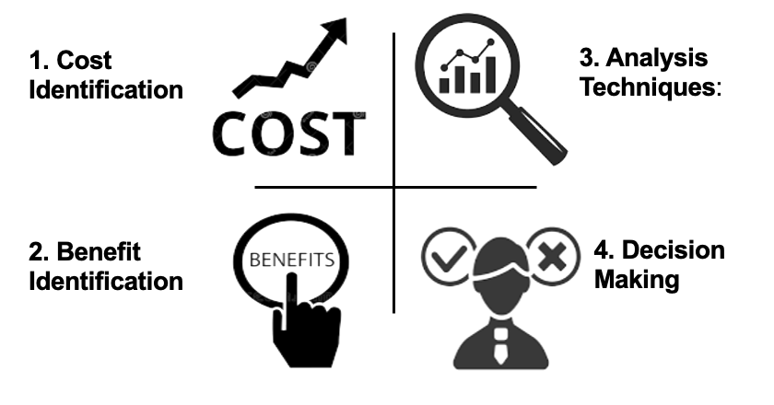**Key Concepts**

1. **Cost Identification**:
   * **Technology Costs**: Assess expenses for new software, platforms, or hardware. For example, implementing an AI-driven chatbot to handle customer inquiries.
   * **Training Costs**: Include the cost of training staff on new tools or systems, such as a new CRM platform.
   * **Operational Costs**: Consider ongoing expenses such as maintenance, updates, and additional staffing needed for extended support hours.
2. **Benefit Identification**:
   * **Increased Customer Satisfaction**: Enhanced CX features, like faster response times or personalized services, can lead to higher customer loyalty.
   * **Revenue Growth**: Improvements in customer experience can drive sales and increase customer lifetime value. For example, a more intuitive e-commerce platform could lead to higher conversion rates.
   * **Cost Savings**: Automation and efficiency improvements, such as chatbots handling routine inquiries, can reduce operational costs over time.
3. **Analysis Techniques**:
   * **Net Present Value (NPV)**: Calculate the present value of the expected benefits minus the costs to determine the overall financial impact.
   * **Return on Investment (ROI)**: Assess the profitability of the investment by comparing the expected returns to the costs.
   * **Payback Period**: Determine how long it will take for the benefits to repay the costs.
4. **Decision-Making**:
   * Based on the analysis, decide whether to proceed with the CX improvements. For example, if the ROI is significantly positive and the payback period is short, the investment is likely worthwhile.

**Digital CX Cost-Benefit Analysis Example:**



**Shopee's AI-Powered Recommendation Engine**

**Background**: Shopee, a leading e-commerce platform in Southeast Asia and Singapore, implemented an AI-powered recommendation engine to enhance its customer experience. The goal was to personalize the shopping experience by suggesting products based on users' browsing history, previous purchases, and preferences.

**Cost Identification**

1. **Technology Costs**:
   * **Software Development and Integration**: Shopee invested approximately $2 million in developing and integrating the AI recommendation engine into its platform. This includes costs for AI algorithms, data infrastructure, and software licenses.
   * **Cloud Infrastructure**: The AI system requires robust cloud computing resources to process and analyze vast amounts of data in real-time. The annual cost for cloud services and data storage is around $500,000.
2. **Training Costs**:
   * **Staff Training**: Shopee allocated $200,000 for training its data scientists, engineers, and customer service teams to effectively implement and maintain the AI system. This includes workshops, online courses, and hands-on training sessions.
3. **Operational Costs**:
   * **Maintenance and Updates**: The company estimates annual maintenance costs of $100,000 for software updates, troubleshooting, and ongoing algorithm improvements.

**Benefit Identification**

1. **Increased Customer Satisfaction**:
   * **Personalized Shopping Experience**: By offering tailored product recommendations, Shopee has seen a 20% increase in customer satisfaction ratings, as customers find it easier to discover products that match their interests.
2. **Revenue Growth**:
   * **Sales Increase**: The AI-powered recommendations have led to a 15% increase in average order value, resulting in an estimated $50 million additional revenue annually across all markets.
   * **Customer Retention**: Personalized recommendations have improved customer retention rates by 10%, translating to a significant increase in lifetime customer value.
3. **Cost Savings**:
   * **Efficiency Gains**: Automation of product recommendations reduces the need for manual curation, saving an estimated $300,000 annually in operational costs.

**Analysis Techniques**

1. **Net Present Value (NPV)**:
   * **Calculation**: Shopee calculated the NPV of the AI-powered recommendation engine by estimating the total future cash flows generated by the system (including increased sales and cost savings) and discounting them back to their present value.
   * **Result**: With an initial investment of $2.8 million and expected annual benefits of $50 million, the NPV was highly positive, indicating a strong financial return on investment.
2. **Return on Investment (ROI)**:
   * **Calculation**: The ROI was calculated by dividing the net profit generated by the AI system by the total investment cost.
   * **Result**: The ROI was approximately 1700%, demonstrating that the investment was highly profitable.
3. **Payback Period**:
   * **Calculation**: The payback period was determined by dividing the initial investment by the annual net benefits generated by the system.
   * **Result**: Shopee’s investment in the AI-powered recommendation engine paid for itself within the first few months, given the substantial increase in revenue and cost savings.

**Conclusion**

Shopee's implementation of an AI-powered recommendation engine exemplifies a successful digital CX cost-benefit analysis. The high ROI, rapid payback period, and significant revenue growth justify the investment. This example demonstrates how a carefully conducted cost-benefit analysis can guide strategic decisions, ensuring that digital CX improvements deliver measurable benefits to both the company and its customers.

## 4.2: Digital CX Strategy Effectiveness Evaluation

Evaluating your digital CX strategies involves identifying and addressing gaps between your organization’s customer experience and that of competitors. This analysis is key to continuous improvement and maintaining a competitive edge in the market

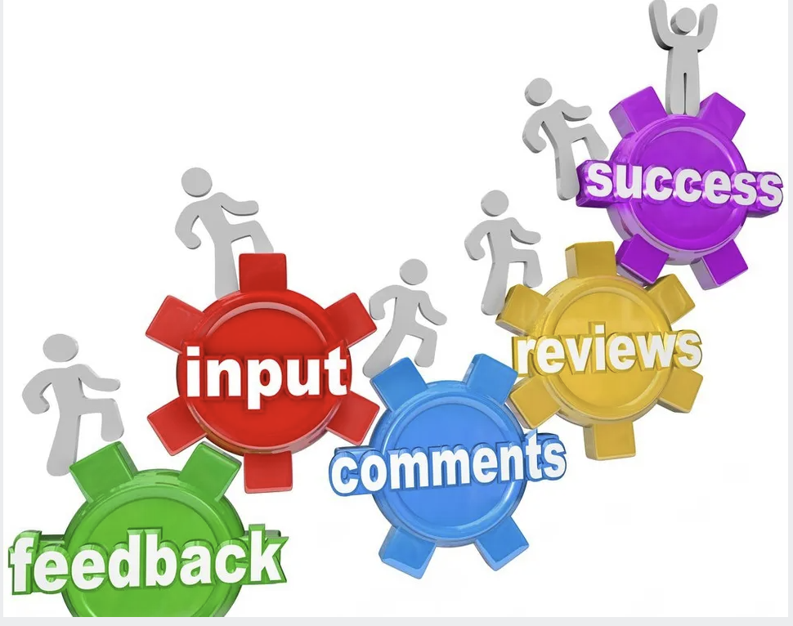

1. **Gap Analysis**:
   * **Customer Feedback**: Collect and analyze feedback from your customers to identify areas where your CX might be lacking. Common sources include surveys, reviews, and direct customer interactions. For instance, if customers frequently complain about long response times, this signals a gap in service that needs to be addressed.
   * **Performance Metrics**: Measure your CX performance using key metrics such as Net Promoter Score (NPS), Customer Satisfaction (CSAT) scores, and Customer Effort Score (CES). Compare these metrics to industry benchmarks and competitor performance to identify gaps. For example, if your NPS is lower than the industry average, it may indicate that your customer experience is not meeting expectations.
   * **Feature Comparison**: Analyze the features and services offered by your competitors. If your competitors are offering advanced features like 24/7 customer support via chatbots or personalized user experiences, and your organization is not, this indicates a gap that could lead to customer dissatisfaction or loss of market share.
2. **Competitive Benchmarking**:
   * **Industry Standards**: Research and compare your organization’s CX performance with industry standards. This involves understanding what the baseline expectations are within your industry and ensuring your CX strategy meets or exceeds these standards. For example, in the banking sector, quick digital transactions and seamless mobile app experiences are standard; falling behind in these areas could hurt your customer retention.
   * **Direct Competitor Analysis**: Conduct a thorough analysis of your direct competitors’ CX strategies. This includes examining their digital presence, customer service practices, and how they engage with customers across different platforms. For instance, if a competitor has a highly rated mobile app with features that your app lacks, this could be a critical gap to address.
3. **Strategic Adjustments**:
   * **Closing the Gaps**: Once gaps are identified, develop strategies to close them. This could involve adopting new technologies, enhancing existing digital platforms, or refining customer service processes. For example, if your analysis shows that competitors offer more personalized experiences, you might invest in AI-driven personalization tools to match or exceed their offerings.
   * **Continuous Improvement**: CX strategy is not static; it requires ongoing evaluation and adjustment. Regularly review performance metrics and customer feedback to adapt your strategy to evolving customer needs and technological advancements.

**Example**: A telecommunications company conducted a gap analysis and found that while competitors offered seamless online account management and 24/7 customer support, their own services were lacking in these areas. Customer feedback highlighted frustration with the limited support hours and outdated online platform. In response, the company invested in a new customer portal and extended support hours, significantly improving customer satisfaction and reducing churn rates.

**Digital CX Evaluation Framework**

|  |  |  |  |  |  |
| --- | --- | --- | --- | --- | --- |
| **Evaluation Criteria** | **Current State** | **Competitor Benchmark** | **Identified Gap** | **Proposed Improvement** | **Expected Benefit/ROI** |
| **Customer Feedback** | Frequent complaints about response times | Faster response times, 24/7 support | Slow response time leading to dissatisfaction | Implement AI-driven automated response system | Faster issue resolution, reduced complaints, High ROI - Expected to reduce churn by 10% |
| **Performance Metrics** | NPS: 50, CSAT: 70% | NPS: 70, CSAT: 85% | NPS and CSAT lower than industry average | Enhance customer service training, improve digital support | Increased satisfaction, loyalty, improvement by 15% |
| **Mobile App Features** | Basic features, slow performance | Advanced, personalized features | Lacks personalization and speed | Upgrade app with AI-driven personalization | Increased engagement, faster performance, by 20% engagement increase |
| **Customer Support Availability** | 8 hours/day | 24/7 via chatbots | Limited availability compared to competitors | Implement 24/7 chatbot support | Increase satisfaction level by 15%, Improve CSAT by 15% |
| **Strategic Adjustments** | Ad-hoc improvements | Continuous innovation in CX | Reactive rather than proactive approach to CX | Develop a continuous improvement plan | Enhanced experience, Increase competitive edge, 10% increase customer retention |

## Learning Activity 4 (Role Play) – Evaluating and Improving Digital Customer Experience

Return to your group of 4 to 5 learners,

1. **Evaluate Your Digital CX:**Compare your organization’s current digital CX performance against competitors, focusing on customer feedback, key performance metrics, and digital platform features.
2. **Propose Strategic Improvements:**Based on your evaluation, identify gaps and suggest actionable improvements. Assess the expected benefits and ROI for each proposed change.
3. Use the template below for your evaluation

**Template 4**

|  |  |  |  |  |  |
| --- | --- | --- | --- | --- | --- |
| **Evaluation Criteria** | **Current State** | **Competitor Benchmark** | **Identified Gap** | **Proposed Improvement** | **Expected Benefit/ROI** |
| **Customer Feedback** | *Frequent complaints about response times*  High  Mid  Low | *Faster response times, 24/7 support*  Yes  No |  |  |  |
| **Performance Metrics** | NPS: 50, CSAT: 70% | NPS: 70, CSAT: 85% | NPS and CSAT lower than industry average | Enhance customer service training, improve digital support | Increased satisfaction, loyalty, improvement by 15% |
| **Mobile App Features** |  |  |  |  |  |
| **Customer Support Availability** | *How many hours a day?* | *24/7 via chatbots*  Yes  No |  |  |  |
| **Strategic Adjustments** | *Got any ad hoc upgrade? Improvements*  Yes  No | *Continuous innovation in CX*  Yes  No |  |  |  |